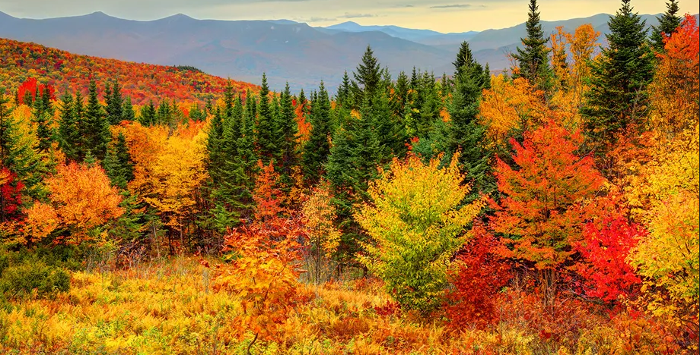

**FLORENCE BOULEVARD**

**CHURCH OF CHRIST**

**November 5, 2023**

**GOSPEL MEETING WITH BARRY GILREATH**

THEME:  THE ABUNDANT LIFE

Sunday

9:00 - The Abundant Life

10:00 - Pillars of a Great Marriage

6:00 - Finishing Marriage Well

Monday

6:00 - Parenting that Makes a Difference

Tuesday

6:00 - God's Grand Family Plan

Wednesday

6:00 - When the Books Were Open

**LUKE 12-24**

When asked to write this article, I started brainstorming the second half of the book of Luke…just jotting down things that came to mind from recently reading those chapters. I always try to find application to my life in anything I study in scripture. Here’s the list I developed:

* Parables
* Pharisees, scribes, elders trying to catch Him in His words
* His ultimate journey and mission
* Desperately trying to teach His disciples before He departs
* Still had time for those in physical need
* The kingdom of God
* Satan plays a role in man’s life
* Saving right up to the end (thief on the cross)
* Teaching that different people can have the same goal and love one another
* Forgiveness

This is obviously not all-inclusive, but it is what stood out for me. When I started thinking about these things, I tried to imagine being right there in the audience Jesus was addressing, and trying to see the love in His eyes and listen to the desire in His voice for me to truly hear Him.

Sometimes I get caught in the trap of thinking in terms of “them” (1st century disciples), and “me”, as if Jesus had a different purpose and message for different times. His Word is everlasting and He is still The Way, The Truth, and The Life, and because no one can come to the Father by any other means, we have a tremendous responsibility to share Jesus with everyone we can. Let’s pray for each other that we might be bold enough to tell everyone we know about our Savior and what He’s done for us.

By Brian McManus

**Elders**

**Steve Clark**

**Jake VanDyke**

**Ken Vanhorn**

**Mark Willingham**

**Deacons**

**Greg Allen**

**Justin Beckman**

**Kevin Clemons**

**Mike Davidson**

**Kyle Dickson**

**Gregg Elrod**

**Nate Fulmer**

**AJ Gooch**

**David Gooch**

**Will Hodge**

**Brian McManus**

**Jamey Medley**

**Ronnie Putnam**

**Dave Schmidt**

**Mark Vanhorn**

**Minister**

**Austin Johnson**

**Youth Minister**

**John Birdwell**

**College Minister**

**Michael Shifflet**

**Children’s Ministry**

**Coordinator**

**Linda Young**

**Office Manager**

**Monnie Ross**

**2502 FLORENCE BOULEVARD**

**www.florenceblvd.org**

**PHONE (256) 766-3617 email: office@florenceblvd.org FAX (256) 766-3546**

**Worship: Sunday 9:00 am & 5:00 pm; Bible Class 10:15 am; Wednesday: 6:30 pm**



**BY THE NUMBERS**

Sunday AM: 275 / On Line Views: 194

Sunday School: 215 / On Line Views: N/A

Sunday PM: 248/ On Line Views: 154

Wednesday: 199/ On Line Views: N/A

Budget: $14,620

Contribution: $ 14,035

**NOVEMBER MISSIONARY OF THE MONTH**

K.B.B. Chandrapaul

Jack Nelle Institute

Nidamanuuru -521104

Vijayawada, A.P.

India

lovefaithhope@yahoo.com

Please consider sending our missionaries an email, or card, of encouragement.

**December 18, 2022**

**FLORENCE BOULEVARD**

CHURCH OF CHRIST

**Elders**

Steve Clark

Jake VanDyke

Ken Vanhorn

Mark Willingham

**Deacons**

Greg Allen

Justin Beckman

Kevin Clemons

Jeffrey Cox

Mike Davidson

Kyle Dickson

Gregg Elrod

Nate Fulmer

AJ Gooch

Jamey Medley

Ronnie Putnam

Dave Schmidt

Mark Vanhorn

Don Williams

**Minister**

Austin Johnson

**Youth Minister**

John Birdwell

**Secretary**

Sonya Cox

**YOUTH EVENTS**

Look for youth events to be posted in the upcoming days.

Great job young men in leading us in worship last Sunday evening!

You are an encouragement to our congregation!

**AREA EVENTS**

UNA Christian Student Center Annual Benefit Dinner

November 7, 2023 at 7:00 pm at KEESTONE RESORT in Loretto, TN.

Entertainment by Ben and Travis and also some talent by our CSC students

Tickets are $100

Sponsorships opportunities are available.

Call or email the CSC office to purchase tickets or sponsor [unacsf@comcast.net](mailto:unacsf@comcast.net)      256-764-9439

**GOSPEL MEETING**

Please be praying for this effort, inviting others and planning to attend. **Please note that beginning tonight, all meeting times for the evening services this week will begin at 6:00 p.m.**

**FELLOWSHIP MEAL**

We will be having a fellowship meal today after Bible classes. All are encouraged to attend. Fellowship Team #2 is asked to help in setting up for the meal and Fellowship Team #1 is asked to stay and help with the clean up afterwards.

**CHRISTIAN STUDENT CENTER FUNDRAISER**

The UNA Christian Student Center is selling pint jars of Honey for $12.50. The students take all money and buy Christmas presents for kids who have incarcerated parents. They wrap and deliver these gifts to the families before they go home for their Christmas break.

**CHILI COOK-OFF**

Our annual chili cook-off will be November 19th after evening services. Men, get your chili recipes and the names for your chili ready for the challenge! Ladies, please bring fixings for the chili, sandwiches and desserts.

**THANKSGIVING BASKETS**

Just a reminder to submit names to Austin Johnson, or Will Hodge, by November 12th, for those who may benefit from receiving a basket filled with ingredients for a Thanksgiving meal.

YOUTH

FLOBO